GoBear - Test Plan

Document Author(s):
Nha Nguyen
Release Date:
31.05.2019
Master Plan
Link to Master Plan
Scope of Release
Link to Scope

I. Introduction

This serves as the plan for testing all software artifacts as well as the reporting of test results.

II. Test Plan

- Test Scope
Define Test Type and test cycle used in this project
Define scope of feature of test:
+ Device of scope: Software, hardware( version, specific device,...)
+ Browser of scope
+ Feature of scope
Define all feature out of scope

2. Test Metric for Automation
Should be review all manual test case
This phase will be checked manual test case feasible automation or not
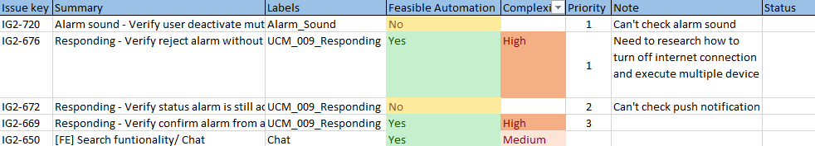

Metric for test cases

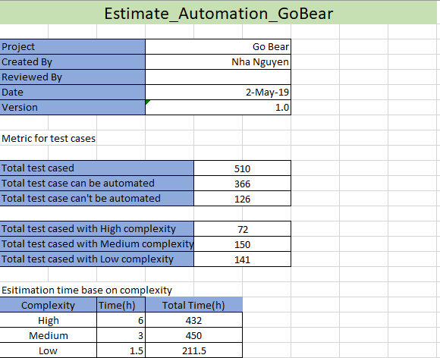

III. Testing Deliverables

Specify the planned testing deliverables which may include:
• Test Case Specification
• Test Log
• Test Summary Report
• Test Input and Output Data

IV. Environmental Requirements

Specify the environmental needs for conducting tests:
• Hardware and system software, other supplies, etc.
• Level of security
• Testing tools

V. Staffing

Specify testing responsibilities, staffing and training needs.

VI. Schedule

Specify testing schedule.

VII. Risks and Contingencies

Specify any potential risks and plans for mitigating, addressing and/or resolving those risks.

VIII. Approvals

List any approvals / signatures required to sign off on test results.

